http://www.art-photograph-gallery.com/still-life-photography-tip.html

Arranging a Still Life By Lisa Anne Misja
There are words sometimes used to describe still life paintings; ‘Not interesting, boring, no movement, still. A beautifully rendered still life is none of these things. Here is a closer look at how to set up a still life.
First, what subject matter should be chosen for the painting? In one respect, the answer to that question could be ‘anything’. You can paint a crumpled paper bag. If it is rendered well, it can turn out to be a beautiful painting. On the other hand, it helps to pay attention to the shapes and the color and the texture of the objects you choose to paint. If a soft plumy feather holds your attention, and you want to paint it, then choose a composition that will accommodate its long length. If it is too tall, set it aside, and keep it in mind for the next painting.
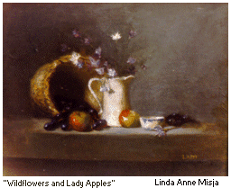
Pay attention to the size of the objects. There should be some subjects that are similar in size, such as several pieces of fruit. Be careful not to choose too many that are too close in size and shape. Sometimes it is interesting to select objects that repeat a shape throughout the design. The round shape of a red onion might repeat the round shape of a standing plate. A larger, bulkier piece is essential to give the painting a good anchor point. For example, a teapot, a rough textured basket turned on its side can be used face front, or there might be a tumble of antique books. The larger item will give the painting stability and provide nice mass for the center or slightly off center position in the work.
Now you will need some height. A taller coffee pot, such as in the painting Flow Blue and Pewter, can satisfy the need for both bulk and height. Think about the colors of the objects. Do they harmonize? If you are not sure, look at a color wheel. Opposites on the color wheel harmonize. Be sure to have smooth textured items along with rough ones.
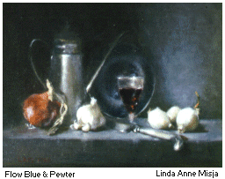
As you choose these objects and begin to arrange them, you are setting up your still life in a classical balanced composition. Now for a tall object. A classic traditional composition is based on the geometric shape of a triangle. Look closely at wonderful still lifes by Master painters that have remained in view throughout history. They are arranged with the summit peak of the triangle at the top. Put the larger, taller object in the center, or slightly off-center of your composition. Everything else will tumble away from it. Objects on the edges of your still life act as both the bottom corners of the triangle and the anticlimax to your focal point.
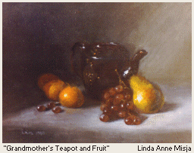
As objects are placed in the set up, think about movement. Light emanating from the upper left that plays on the objects will affect each one in varying levels of intensity. The harmonizing colors and light that moves around the objects supplying motion to your painting when you stand back and look at your set up. The objects chosen suggest a mood. Emotion the artist wants to evoke in the viewer has been created by him or her with careful planning and design.

